**PRACTICAL – 7(5)**

**Aim: Write a program to create three threads ‘FIRST’, ‘SECOND’, ‘THIRD’. Set the priority of the ‘FIRST’ thread to 3, the ‘SECOND’ thread to 5(default) and the ‘THIRD’ thread to 7.**

**SOURCE CODE:**

public class Practical_7_5 extends Thread {

    public static *void* main(String[] *args*) {

        Practical_7_5 t1 = new Practical_7_5();

        Practical_7_5 t2 = new Practical_7_5();

        Practical_7_5 t3 = new Practical_7_5();

        System.out.println("Current Priority of Threads: ");

        System.out.println("Priority of Thread 1: " + t1.getPriority());

        System.out.println("Priority of Thread 1: " + t2.getPriority());

        System.out.println("Priority of Thread 1: " + t3.getPriority());

        System.out.println();

        t1.setPriority(3);

        t2.setPriority(5);

        t3.setPriority(7);

        System.out.println("Priorities of Threads After Setting New Priorities: ");

        System.out.println("Priority of Thread 1: " + t1.getPriority());

        System.out.println("Priority of Thread 1: " + t2.getPriority());

        System.out.println("Priority of Thread 1: " + t3.getPriority());

        System.out.println("\n20DCE019-Yatharth Chauhan");

    }

}

**OUTPUT:**

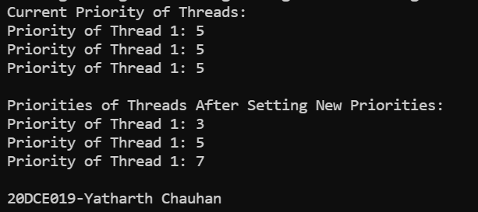

**CONCLUSION:** In this practical we can use 2 methods to get name and priority of our thread and another 2 methods to set the name and priority of the thread apart from the default name and priorities given by system.